Aim: Perform basic Image Handling and processing operations on the image.

Objectives: The objective of this lab is to introduce the student to OpenCV, especially for

image processing.

• Reading an image in python

• Convert Images to another format

• Convert an Image to Grayscale

• Play a video file

Experiment No. 1 Date:

Aim: Perform basic Image Handling and processing operations on the image.

Objectives: The objective of this lab is to introduce the student to OpenCV, especially for

image processing.

• Reading an image in python

• Convert Images to another format

• Convert an Image to Grayscale

• Play a video file

Some Useful Commands:

1. To slice a 2D array: x = y [row_start: row_ end, col_start: col_end]

2. To create a 2D array of zeros using NumPy: my_array = numpy.zeros ((row, columns),

dtype=numpy.uint8)

3. To create a 2D array of ones using NumPy: my_array = numpy.ones ((row, columns),

dtype=numpy.uint8)

4. To check th

Computer Vision with Open CV LAB Experiments

1. Perform basic Image Handling and processing operations on the image.

• Read an image in python and Convert an Image to Grayscale

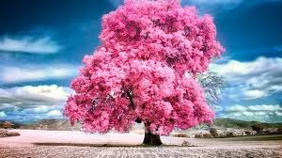

2. Perform basic Image Handling and processing operations on the image

• Read an image in python and Convert an Image to Blur using GaussianBlur.

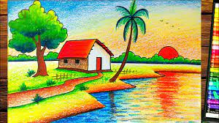

3. Perform basic Image Handling and processing operations on the image

• Read an image in python and Convert an Image to show outline using Canny function.

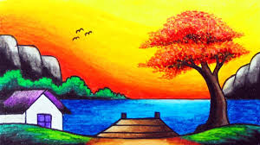

4. Perform basic Image Handling and processing operations on the image

• Read an image in python and Dilate an Image using Dilate function.

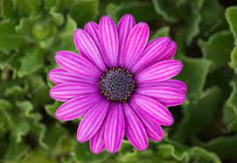

5. Perform basic Image Handling and processing operations on the image

• Read an image in python and Erode an Image using erode function.

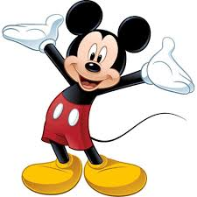

6. Perform basic video processing operations on the captured video

• Read captured video in python and display the video, in slow motion and in fast motion.

7. Capture video from web Camera and Display the video, in slow motion and in fast motion.

8. Scaling an image to its Bigger and Smaller sizes.

9. Perform Rotation of an image to clockwise and counter clockwise direction.

10. Perform moving of an image from one place to another.

11. Perform Affine Transformation on the image.

12. Perform Perspective Transformation on the image.

13. Perform Perspective Transformation on the Video.

14. Perform transformation using Homography matrix.

15. Perform transformation using Direct Linear Transformation.

16. Perform Edge detection using canny method

17. Perform Edge detection using Sobel Matrix along X axis

18. Perform Edge detection using Sobel Matrix along Y axis

19. Perform Edge detection using Sobel Matrix along XY axis

20. Perform Sharpening of Image using Laplacian mask with negative center coefficient.

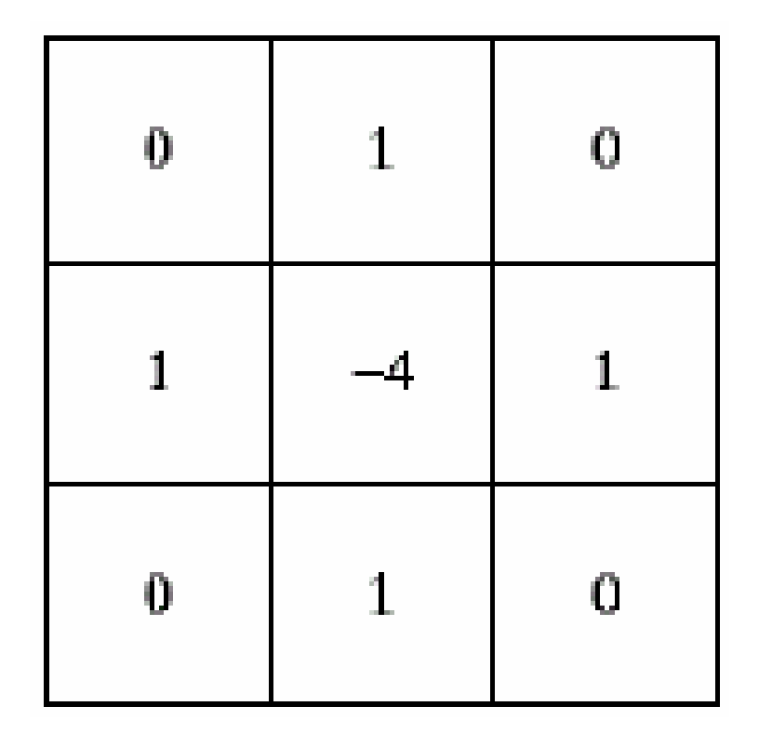

21. Perform Sharpening of Image using Laplacian mask implemented with an extension of

diagonal neighbors,

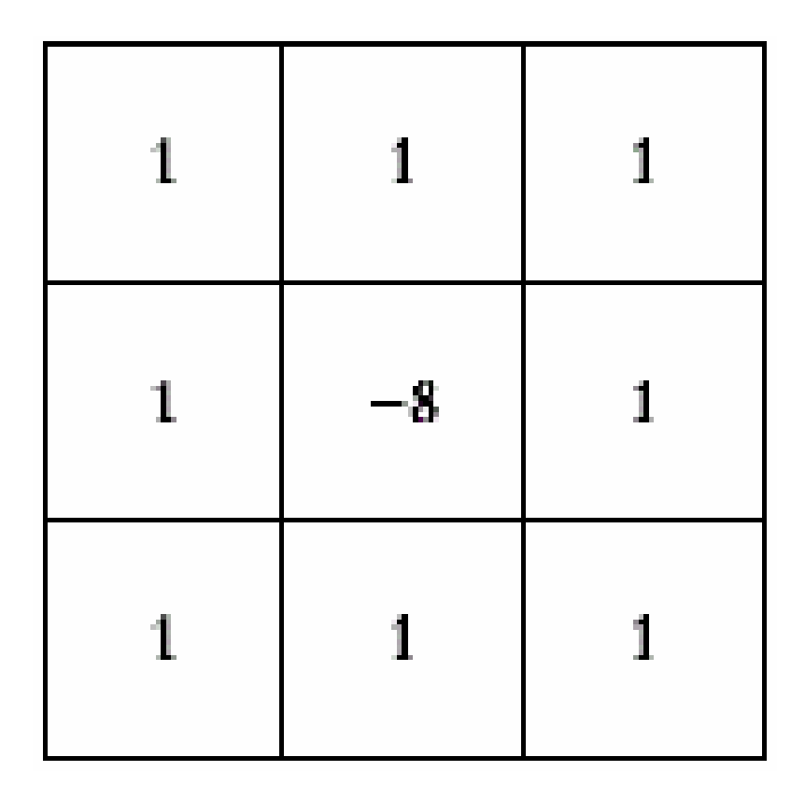

22. Perform Sharpening of Image using Laplacian mask with positive center coefficient.

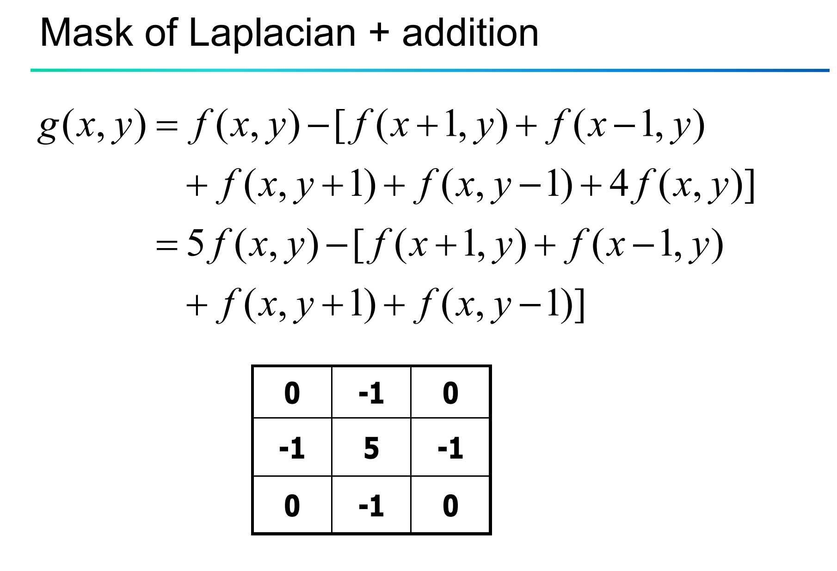

23. Perform Sharpening of Image using unsharp masking.

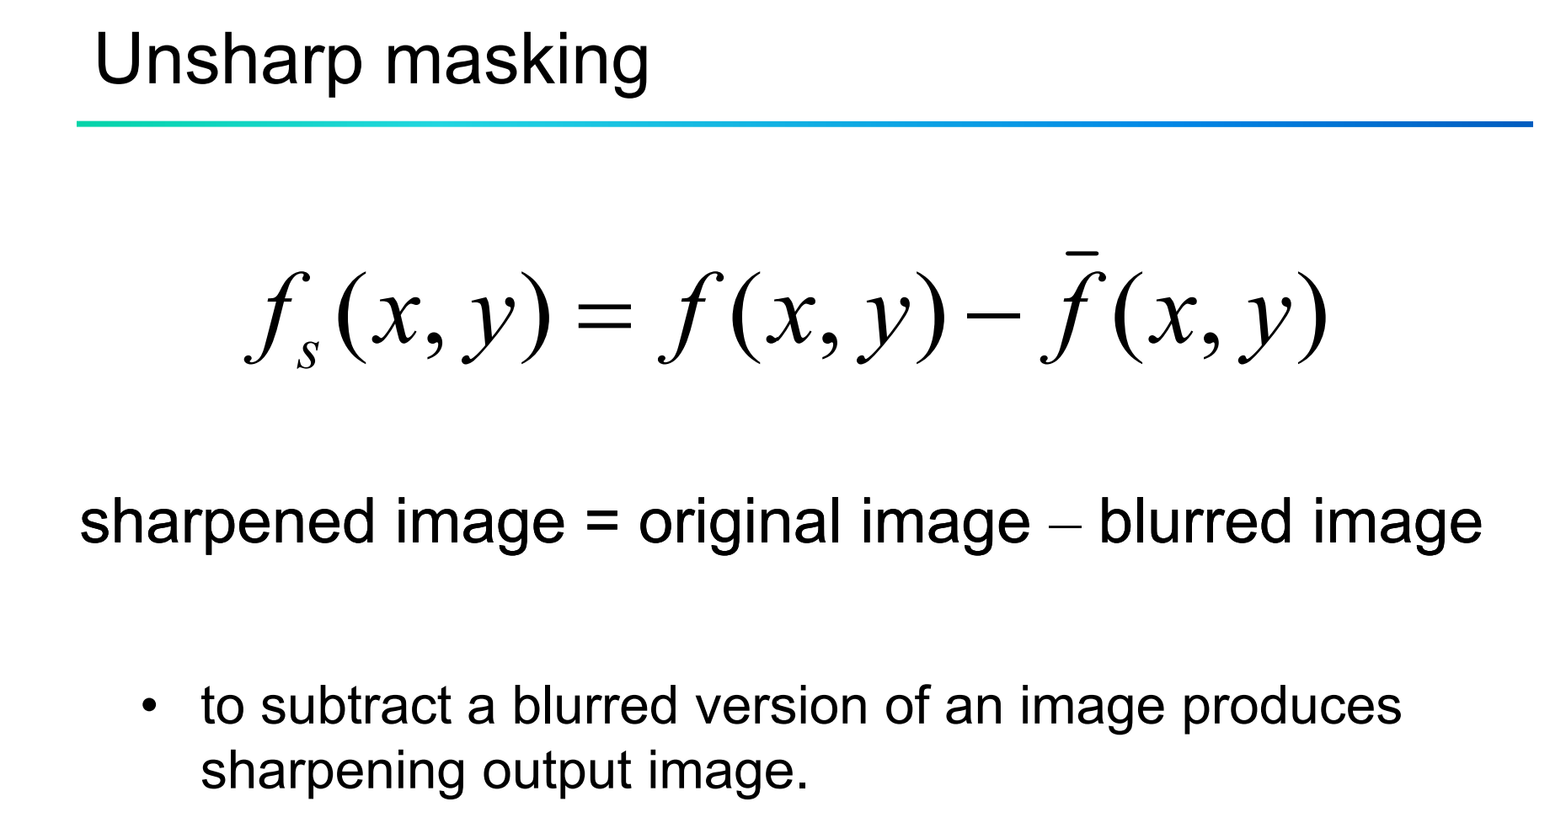

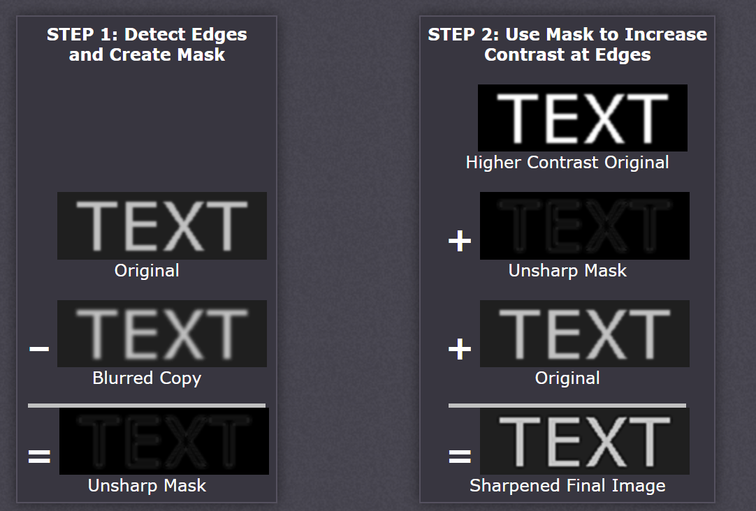

24. Perform Sharpening of Image using High-Boost Masks.

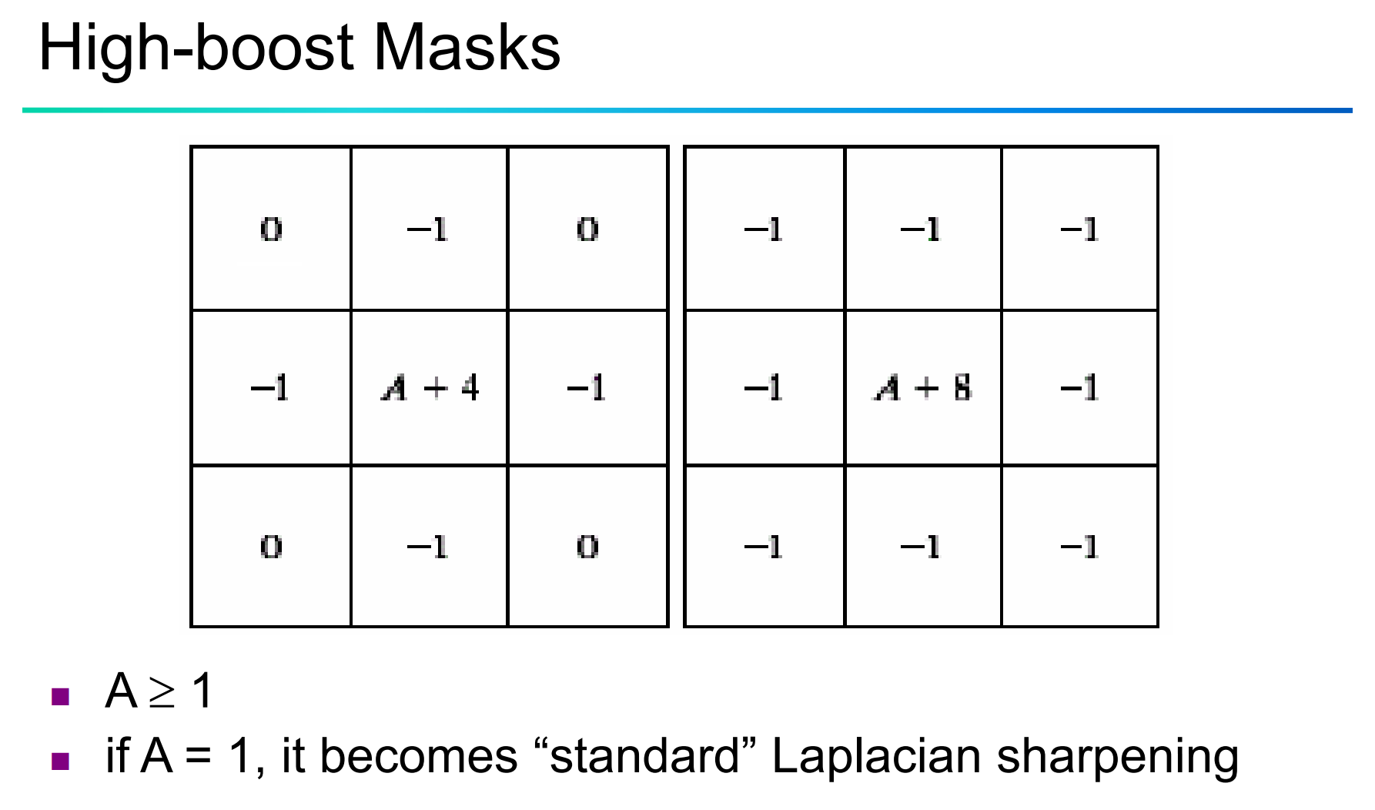

25. Perform Sharpening of Image using Gradient masking.

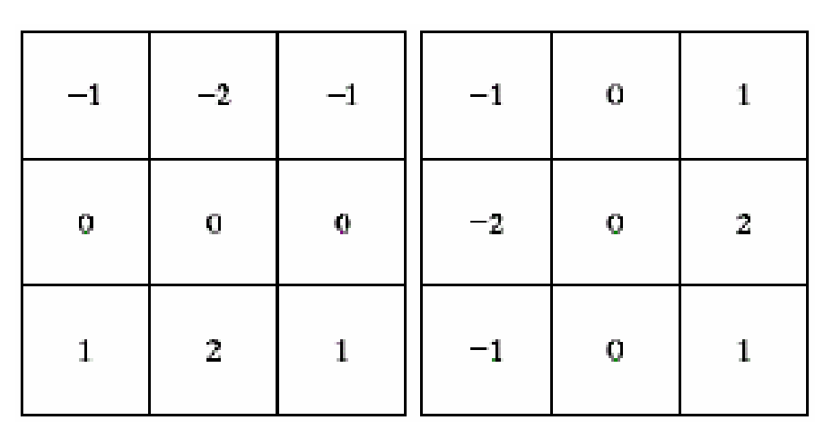

26. Insert water marking to the image using OpenCV.

27. Do Cropping, Copying and pasting image inside another image using OpenCV.

28. Find the boundary of the image using Convolution kernel for the given image.

29. Morphological operations based on OpenCV using Erosion technique.

30. Morphological operations based on OpenCV using Dilation technique.

31. Morphological operations based on OpenCV using Opening technique.

32. Morphological operations based on OpenCV using Closing technique.

33. Morphological operations based on OpenCV using Morphological Gradient technique.

34. Morphological operations based on OpenCV using Top hat technique.

35. Morphological operations based on OpenCV using Black hat technique.

36. Recognise watch from the given image by general Object recognition using OpenCV.

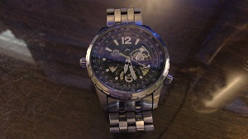

37. Using Opencv play Video in Reverse mode.

38. Face Detection using Opencv.

39. Vehicle Detection in a Video frame using OpenCV .

40. Draw Rectangular shape and extract objects.

